(Approx. 1,434 words)

Windows 8.1 - My First Look
By Lynn Page, Editor, Crystal River Users Group, Florida
December 2013 issue, CRUG newsletter
www.crug.com
lpage46 (at) tampabay.rr.com

I decided to look at Windows 8 without reading any instructions or viewing any help videos. So this article is about my very first look at the operating system. For those of you experienced with it I apologize for my lack of using the proper terminology.

The computer booted to a very pretty screen with nothing but the date displayed. Clicking the mouse, pressing enter or the space bar, or basically anything I thought of trying moved on to the log in screen. Alfred set up an account for me so I selected it from the list of accounts. After that I entered my email address and password which got me to my Start Screen and a first look at Windows 8.1.

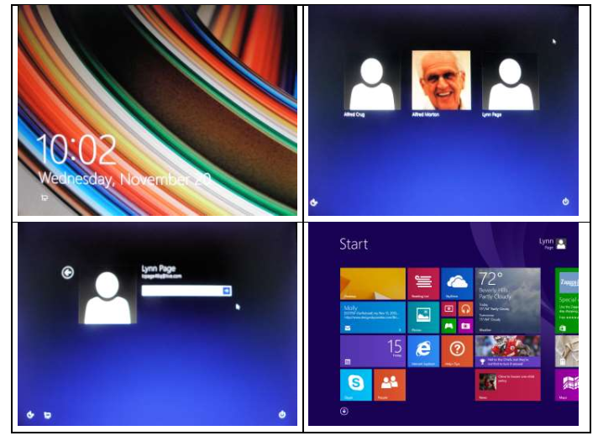

The graphical interface is made up of tiles covering more space than the screen shows so you scroll through the screen, and select a tile to open the associated application. On this desktop computer I could use the scroll bar or mouse wheel to move backwards and forwards through the screen and click on a tile to open it. The Home or End keys on the keyboard jump from one end of the Start screen to the other.

I looked at most of the applications from the Start Screen and found using Windows 8.1 with them fairly intuitive. Some I wouldn’t use so I didn’t spend much time on them. The applications open to full screen and there is not a way to resize them. It is visible full screen or minimized and not shown.
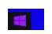
Once in an application I found that putting the mouse in the lower left corner showed a button to return to the Start Screen. Clicking the Windows key on the keyboard also returned to the Start screen. This minimizes the application but does not close it.

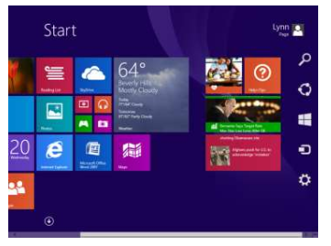
I should mention that I found the Start Screen button and Side Bar quickly because in experimenting I was moving the mouse all around the screen. To me that seemed an obvious thing to do as some of the applications I use dock their palettes and toolbars in this manner. I am also used to right clicking anytime I feel that I might get some help and it did by providing access to options and customizations.

Moving the mouse to the right hand corners while on the Start Screen or an application screen displays a side bar with icons for Settings, Devices, the Start Screen, Share and Search. The Settings available are application dependent. So to make changes click the Settings icon on the side bar accessed from the application you want to change.

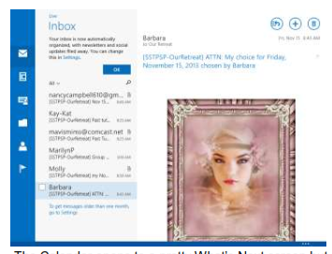
The Mail tile brought up screens that walked me through connecting to one of my Microsoft accounts. If you don’t have a Microsoft account the application provides help in setting one up. Since login is based on an email address and password this changed my account login. I went through part of the procedures. After linking to my account I went with the default settings of using SkyDrive as my file storage location. I didn’t link to friends or social networks as I am using Alfred’s computer for this learning experience. I can easily do that when I get a Windows 8 machine. I really liked the Mail display as it even shows gifs. Use the side bar to personalize email settings.

The Calendar opens to a pretty What’s Next screen but right clicking shows other display options. Here I chose monthly. Other options include day, week and work week. Add an event by clicking on the date or time based on the calendar view and add the information. Clicking on an event opens the event where additional information is entered.

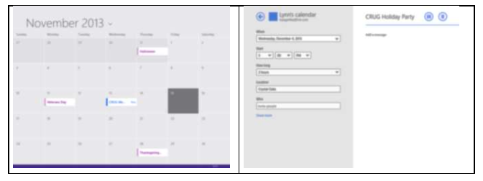

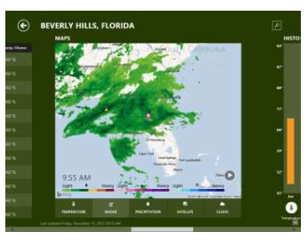
The Weather application is Bing Weather and was easy to use. The ‘home location’ current weather is displayed right on the Start Screen on the Weather tile. So there is no need to open Weather to get a quick glimpse of the current conditions or forecast for the day. I liked the weather map and historical data provided along with current conditions. As with all of the screens you just scroll through to see the information.

Changing the Home Location or adding additional places wasn’t straight forward. Scroll to the far right of the screen and click Change Home Location to set your default place. My Places also lets you change the Home location by clicking the tile below the current Home and entering the information. Click the + tile to add a new location.
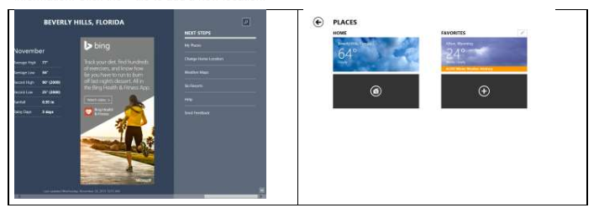
The Sports, News and Finance applications were equally as straight forward to use but I didn’t spend much time on them. Clicking on the Internet Explorer tile opened IE full screen, as all of the Start Screen apps do. This was the one place that took me a bit of time to figure out. I didn’t find some actions obvious. First there wasn’t an address
bar. To find it move the mouse to the bottom of the screen and an Address Bar button appears. Clicking the ‘star icon,’ Favorites, opens a listing of favorites. Clicking the ‘star+ icon’, Add to Favorites, opens a dialog to add the current site to favorites. The favorites listing can be organized in folders. Clicking the ‘push pin icon’, Pin Site, places the site on the Start Screen.

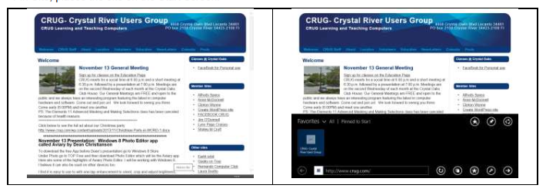
Setting my homepage was a bit of a trial. While on the web site, move to mouse to one of the right corners to show the side bar. Click the Settings icon and then Options. In the dialog box under Home Page click Customize. Finally click the Add current site button. If you have multiple Home pages set they are shown in the dialog box. To remove one select it and click Remove.

Other icons on the Address Bar are Refresh, New Tab, and Page Tools. Finding Options was also a struggle, that’s why reviewing help tutorials is a good idea. I just played with the mouse around the edges and when in very bottom right corner of the Address Bar I found the pop up side bar that includes Settings.
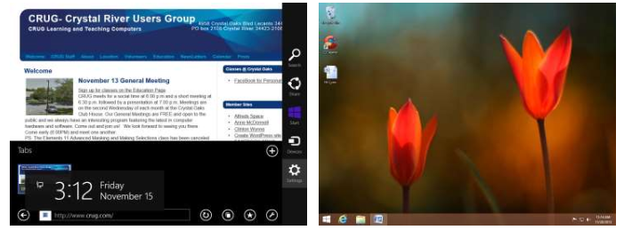
The last of the Start Screen applications I will address in this article is the Desktop. Clicking the Desktop icon moves from the Start Screen display and its associated apps back to a more traditional Windows desktop view.
The Task Bar with pinned applications and Notification area all both there. But the Start or Windows button is replaced with a Start Screen icon. To open an application use File Explorer to browse to and open it. Desktop applications open on the desktop and work as they would in another version of Windows.

In Windows 8 all of the applications, including those not shown on the Start Screen, are available in an Apps tabulation. It is accessed by clicking the down arrow in the bottom left of the Start Screen. The application list can be sorted by Category, Name, Most used or Date installed. I stayed with the default category listing. Clicking an icon from the listing opens the application on the Start Screen or Desktop depending on the type of application being opened.

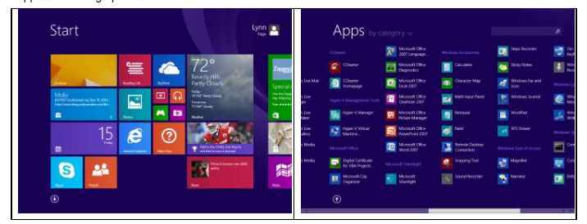
I hadn’t seen Windows Explorer or Computer except pinned to the Task Bar on the Desktop view so was glad to find it in the all Apps listing.

Back on the Start Screen I did some customizing. Right click on a Tile or anywhere on the screen to open Customize. Here you can choose to Unpin a program from Start or even uninstall it. I just Unpinned those I would not use. Adding applications to the Start Screen was also easy and intuitive. Right click the application in the Apps listing and select Pin to Start.

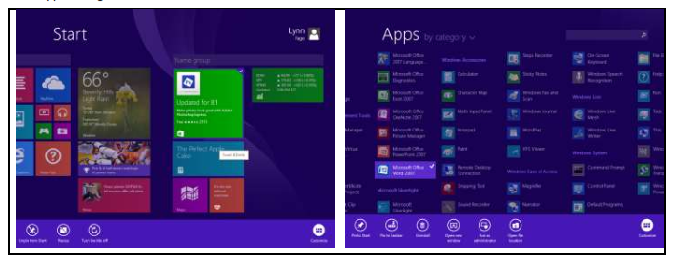

My final topic from this first look at Windows 8.1 is shutting down. I found the easiest way for me was to move the mouse to the lower left corner on the Start Screen to get the Start Screen icon or move over the same icon on the Desktop and right click. On the pop up menu point to Shut down or sign out and then select Shut down.

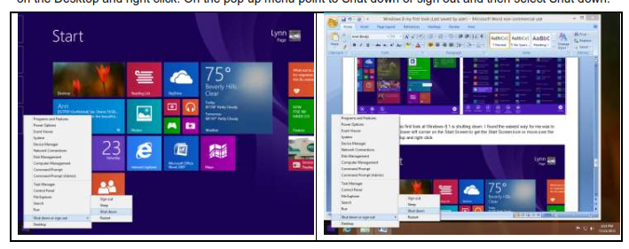

This concludes my comments on the experience of jumping into Windows 8.1 with no training. Since then I have gone through several tutorials from the Windows Store and looked at Help available from the applications. So in future newsletters I will discuss some of the other information I have learned and experience I have had.

